|  |  |  |  |
| --- | --- | --- | --- |
| Name: | ____________________________________ | | Date: *___________* |
|  | **Year 12 Mathematics: Essentials**  **Investigation 1, 2018**  **Topic - Measurement**  **TAKE HOME** | |  |
| **Total Time:** | 4 nights (1 weekend) | / 21  % | |
| **Weighting:** | 7 % |
| **Equipment:** | *Scientific calculator* | | |

**DOSAGES**

Children are more sensitive than adults to medications because of their weight, height, physical condition, immature systems, and metabolism.

**Part 1: [5 marks]**

Infants and young children’s weight in pounds must be converted to kilograms to accurately calculate medication doses and daily fluid requirements.

***The formula: 2.2 lb = 1 kg***

***The formula: 1000 g = 1 kg***

Examples:

15lb = 33 kg -> 15 x 2.2

2560g = 2.560 kg -> 2560 1000

Convert pounds and grams to kilograms (show working out)

1. 27 lb ________ kg

2. 38 lb ________ kg

3. 6 kg _________ lb

4. 5220 g ________ kg

5. 3202 g ________ kg

**Part 2: [10 marks]**

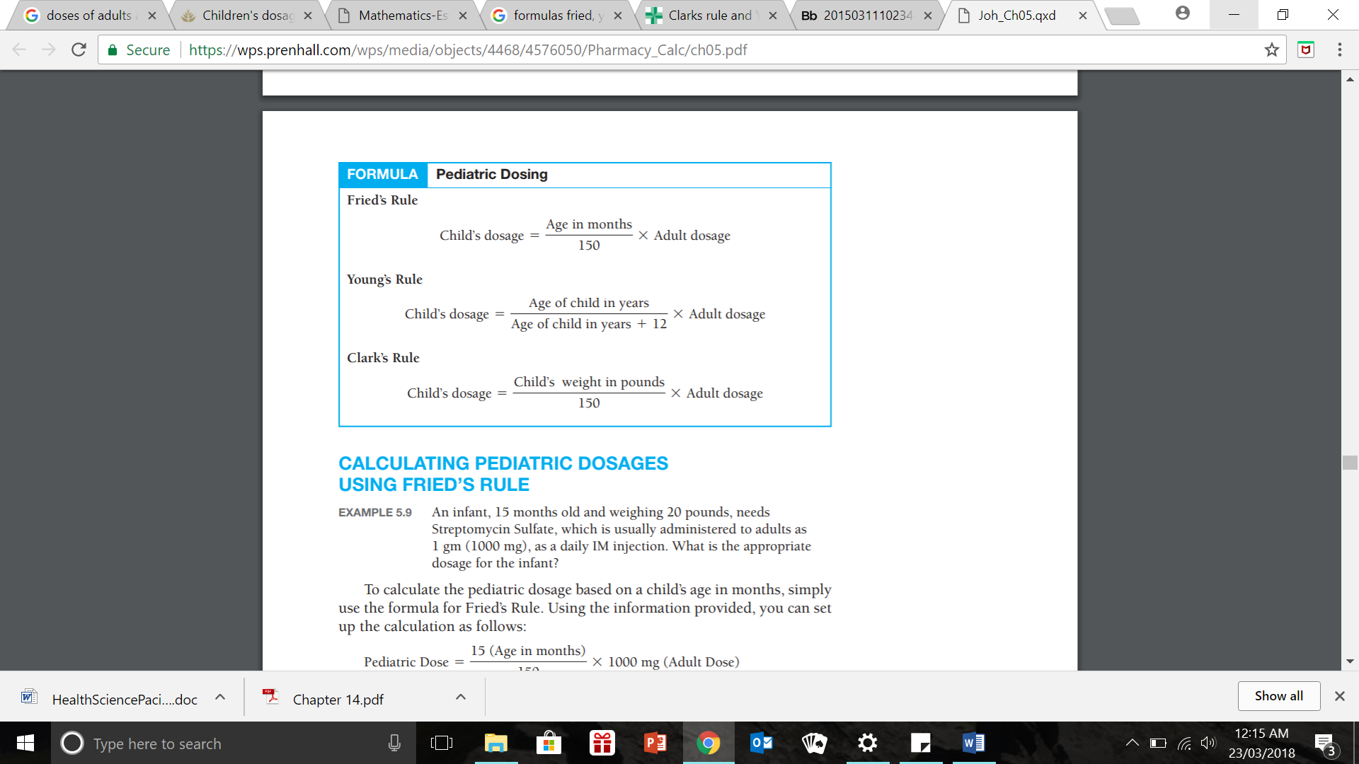

**Fill in the blanks using a word from the brackets.**

1. ___________ for children are generally based on body weight and size.

(Medicine / Dosages)

1. Several different methods may be used to determine the correct dosage of medication for a ___________patient

(paediatric / podiatric)

1. Clarke’s rule is based on the ___________of the child.

(age / weight)

1. Young’s rule is based on the ___________ of the child.

(age / weight)

**Use the formulas above to answer the following questions (show working out).**

1. The doctor orders an adult dose of Amoxicillin 250mg. Use **Fried’s rule** to calculate the dose for a 1-year old child.
2. The doctor orders an adult dose of Ibuprofen 600mg for pain. Use **Young’s rule** to calculate the dose for a 5-year old child.
3. The doctor orders an adult dose of Prednisone 10mg. **Using Clark’s rule**, calculate the dose for a child weighing 42lbs.

**Part 3: [6 marks]**

What is intravenous therapy?

__________________________________________________________________________________________________________________________________________________________________________________________________________________________________________

Intravenous fluid must be given at a specific rate, neither too fast nor too slow. The specific rate may be measured as ml/hour, L/hour or drops/min.

Calculation of Intravenous (IV) Infusions

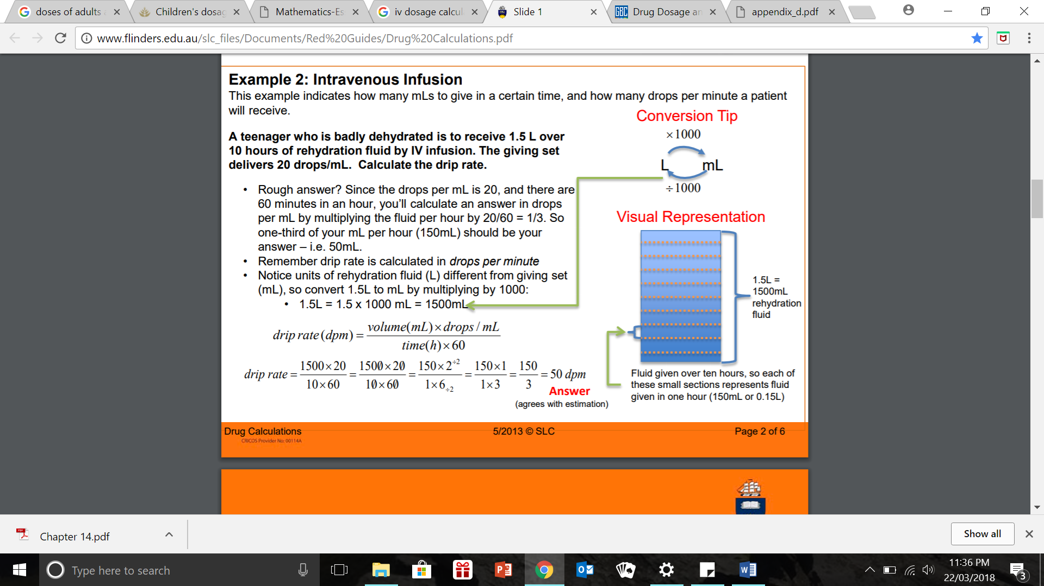

***The formula:***

1. 1200 mL IV is ordered to infuse in 10 hours by infusion pump. Calculate the flow rate in millilitres per hour.
2. 600 mL of antibiotic is to be infused over the 180 minutes by an infusion pump. Calculate the flow rate (mL per hour). **\*\* hint: change 180 mins into hours first!**